1. Make the type of the heading

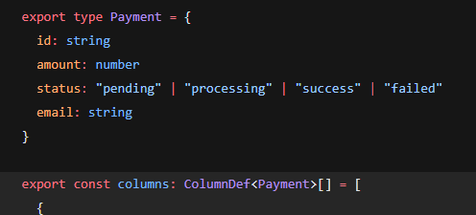

1. Step -2 defining the heading list in a array of objects with type attached to it .

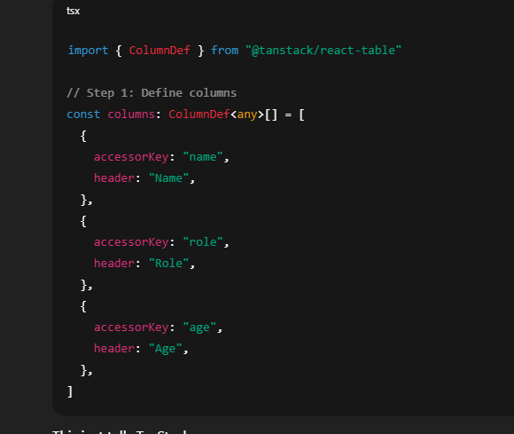

After this we have to create the data

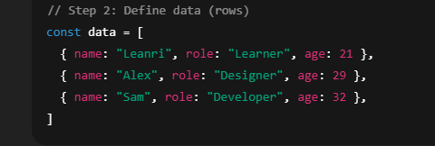

Now we will use the userreacttable hook form tanstack to connect the colums and the data

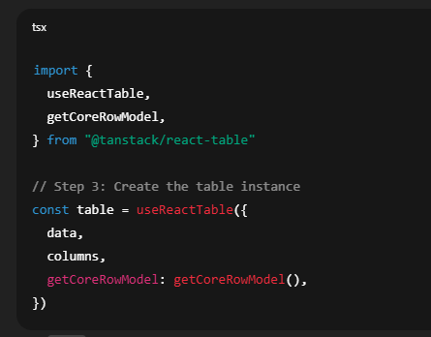

* getCoreRowModel() → tells TanStack how to build the basic table structure (rows, cells)

**✅ Step 4 — Render the table UI with shadcn/ui**

Now that TanStack has given us a table instance, we use it to loop over headers and rows, and render them with shadcn’s Table components.

